Press Release |  |  | 
Publication Date  2015. 6. 30. | Total of 2 Pages | www.nec.go.kr |  | TEL 02) 504-5354
4,614 overseas Korean nationals participate in mock election in preparation for the 20th Overseas National Assembly Election

The National Election Commission announced that the overseas mock election in preparation for flawless management of the 20th National Assembly Election had successfully ended with participation of 4,614 Korean nationals from 167 diplomatic offices worldwide.
The National Election Commission expressed their thanks to Korean nationals who gave meaning to the event by participating in even the mock election.
With the completion of voting, the managers of overseas voting (heads of diplomatic office) use diplomatic bags to send the overseas votes to National Election Commission in Korea. And the National Election Commission sends the votes to 252 borough/city/district election commissions nationwide via registered mail.
Ballot count of mock overseas election is to be performed on July 8 at each borough/city/district election commissions.
The National Election Commission announced that it will reinforce any imperfections prior to October, the full-fledged start of the 20th Overseas National Assembly Election, by analyzing/reviewing the overall process of mock election immediately after the ballot count is completed.
Appendix 1 Photo
[Appendix]
Photo

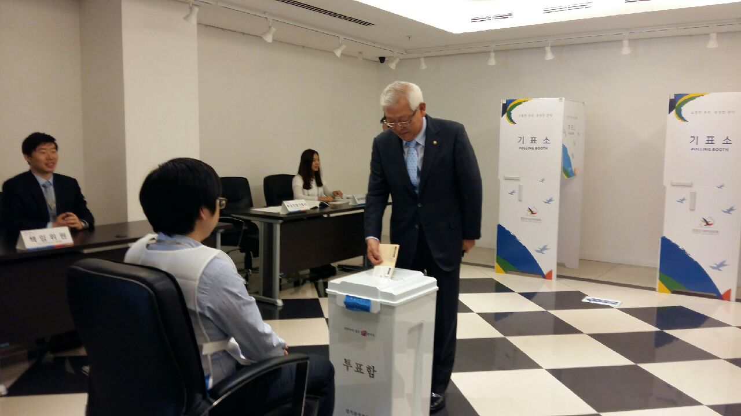
Lee Jong-wu, standing member of the National Election Commission, is casting a vote at the Korean Consulate General in Istanbul on June 29 during his visit to Turkey to attend the mock election.

